English 10 Section 3.3 Assignment
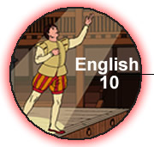 | Name:
 | NBCDES Student Number:
 | Date:
 | Marks: /102 = %

Remember to submit the following with this assignment:
Title From Marks
Part A: The Expository Multi-paragraph Composition Lesson 3.3B 46
Part B: Oral Presentation Lesson 3.3C 34
Part C: Grammar Quick Quiz Lesson 3.3C 10
Part D: Journal Entries Lesson 3.3 12

Mark: /102
Part A: The Expository Multi-paragraph Composition

Instructions
Submit all parts of the personal multi-paragraph composition. Use the checklist below to make sure you have included all of your work.
- Gathering Ideas: Brainstorming, Web or Other Research
- Outline Template
- First Draft with Editing Marks
- Editing Checklist
- Final Copy

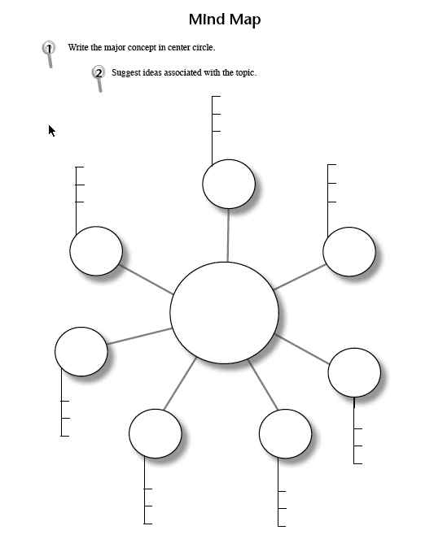

Outline
 |  | Outline
General Statement

 | 
Thesis Sentence
(subject and attitude, use a complete sentence)


Point #1 | Point #2 |  |  | Point #3
  Specifics for support | Specifics for support |  |  | Specifics for support
Concluding Statement

First Draft:

( )
Editing: Checklist
Criteria | Self-Assessment:  have you done this? | Teacher
uses proper sentence format,including capitalization and periods
uses a variety of sentence types
presents each idea in paragraph format
presents ideas in a logical order
supports ideas with facts, evidence, and/or descriptive details
provides an effective opening and conclusion
shows agreement in use of verbs and pronouns
uses verb tenses properly
uses punctuation correctly, including commas, quotation marks, periods, question marks, and exclamation marks
uses correct word forms
presented in typed or legible handwriting

Final Copy: Copy and paste your first draft here. Make your revisions in the final copy below.
( )
Part B: Oral Presentation
Your assignment is to create a 2 - 3 minute oral and visual presentation on the topic you completed your multi-paragraph composition on in the previous lesson. Review Lesson 2.3C: Speak Your Mind for specific instructions.

As part of your presentation, you will be required to submit:

• speaking notes for the oral presentation
• supporting visuals, or photos of these visuals for the oral presentation (i.e. computer slide show such as PowerPoint, poster, etc.)
• presentation itself - Design your speech for your teacher, your class, or to an audience of your choice. Your presentation should show evidence of careful planning and practice. When applicable, videotape or make an audio recording of the presentation and submit the recording. (If you cannot record the presentation, contact your teacher who may arrange to meet with you or to hear your presentation over the phone.) You can do your presentation in a number of different ways. Please contact your teacher to let him/her know what you plan to do.

A) Speaking Notes:
( )

Part C: Grammar Quick Quiz

Instructions
A. Identify if the subject-verb agreement is correct, or incorrect, in the following sentences:

( ) 1) Angelina, Tara, and Lori likes to go to the cinema.
correctorIncorrect

( ) 2) Tea, coffee, or juice is served with breakfast.
correctorIncorrect

( ) 3) In the play, Romeo and Juliet, there is multiple acts.
correctorIncorrect

B. Indicate if the following sentences are in the active or passive voice.

( ) 4) The questions were answered well by the speaker.
active or passive

( ) 5) Shasta caught the Frisbee with her teeth, good dog!
active or passive

( ) 6) The painting was painted exquisitely by the watercolour artist.
active or passive

( ) 7) Joel marked Pib's test after class.
active or passive

C. Select the correct word form in the following sentences:

8) Let's go on to the ( ).capitolcapital

9) ( ) time to get ready for the birthday dinner tonight.It’sIts

10) The dim light ( ) the quality of the photo.affectedeffected

Part D: Journeal Entries
Instructions
Complete the three Journal for this section below.

Journal Entry 3.3A: Media Messages
- What messages do the two ads give boys about how they should behave?
- These ads are over 15 and 35 years old. Do you think the message for boys is different now, or the same? Explain.
- Does Ryan or Josh seem to follow the code of behaviour taught by the ads? Explain.
( )

Journal Entry 3.3B: Are You Surprised by the Messages?
- Are you surprised by the media messages that Roberts describes in the article?
- Should there be standards as to what the media can portray in advertising?
What is Your View?
Before you complete this lesson, take a few minutes and reflect on the following questions:
- Do you believe that the media influences the way boys act around you? Explain. In your experience, is violence a part of the way boys deal with each other and with girls?
( )

Journal Entry 3.3C: Free Writing
Free-writing means writing down any ideas that come to your mind while you have your pen to paper. You can write in any form, from a list, to a web, to unpunctuated stream-of-consciousness style of writing. Get as many ideas down about the topic as possible.

Choose one of the following topics, set a timer for ten minutes, and simply write.
- People sometimes feel threatened by others who are different, and reject them unfairly, OR
- People who suffer from discrimination do not live full lives.
When the timer rings, reread what you have written and circle any ideas that interest you, which you may fit into the multi-paragraph composition to come.

( )

