English 10 Section 4.1 Assignment
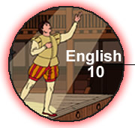 | Name:
 | NBCDES Student Number:
 | Date:
 | Marks: / = %

Remember to submit the following with this assignment:
Title From Marks
Part A: Comparing Traditions Lesson 4.1A 6
Part B: Graphic Ballad Lesson 4.1B 12
Part C: Identifying the Bard’s Images Lesson 4.1C 14
Part D: Dramatic Reading Lesson 4.1C 20
Part E: A Secret and the Keeper - A Comparison Lesson 4.1D 35
Part F: Your Story - Multi-paragraph Narrative Lesson 4.1E 36
Part G: Journal Entries Lesson 4.1 12

Mark: /135
Part A: Comparing Traditions

Introduction
We have considered the two traditions of mythology and oral storytelling. We have looked at the commonalities and differences between Greek myths and the Aboriginal stories and in this assignment, we will use that information to complete a matching activity.

So let’s take a moment to put those traditions together to find out what is common both and what is different about the Greek myths and the Aboriginal stories.

Instructions
Your assignment is to complete the matching activity. Examine each point carefully and decide if the point is relevant to Greek myths only, to Aboriginal stories only, or if the point is common to both traditions.

Take the points listed at the bottom of the page and insert them into the proper sections of the Venn diagram.

•

•

•

•

•

•

• an absence of a specific or god-like hero
• derived from an oral tradition
• focus on gods and heroes
• circular plot structure: without clear beginnings, middles and ends
• a lesson about life is shared
• more traditional plot structure with an emphasis on action

Part B: Graphic Ballad

Introduction

Comic books, or graphic novels, are a popular form of storytelling among both youth and adults today. In the traditional literary ballad, poetic features such as rhyme scheme and stanza structure were critical components of the story composition. In a comic, features such as panels, speech / thought bubbles, illustrations, and captions are critical components of the story composition.

What the comic and traditional ballad have in common are:
- narrative structure: beginning, middle, and end
- focus on action and dialogue
- carefully selected words to commute a message

Instructions

Now that you are familiar with Stan Roger's ballad "White Squall," retell the narrative structure in the form of a graphic ballad. Use the panels, illustrations, and speech / thought bubbles provided to tell the story. Keep in mind that text and illustrations together should communicate more than they could separately!

To complete this graphic ballad:
- provide a meaningful title (own words)
- provide introductory text to set the context (own words)
- trace critical moments of the narrative plot into appropriate panel
- use only direct quotations from the original poem into the bubbles

You are limited in your use of words, so make sure they pack a punch!

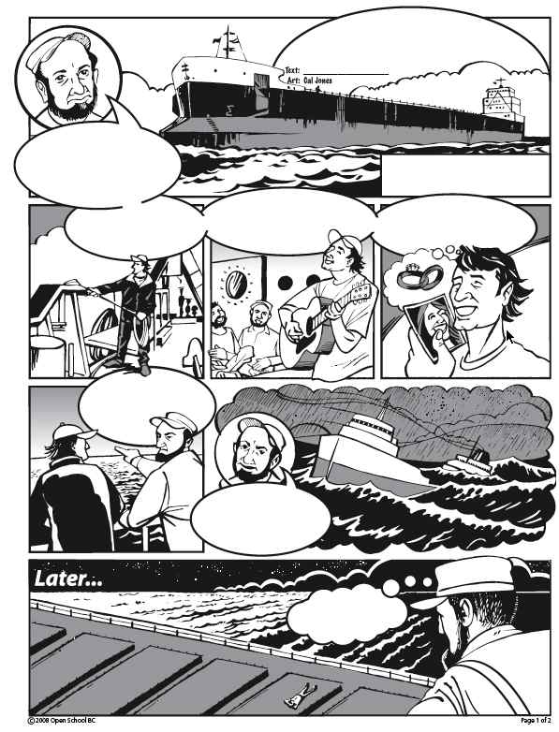

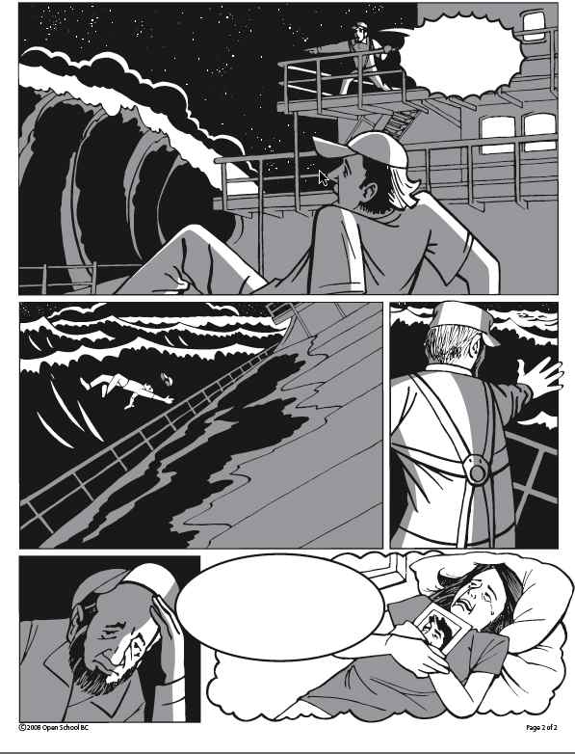

Part C: Identifying the Bard’s Images

Introduction
You've just read and listened to the famous "All the world's a stage" soliloquy, and soon you will be asked to record your own reading of that speech. In order to better prepare you to do a dramatic reading and to make certain you have understood what an image is, you are now going to take a closer look at the soliloquy.

Instructions
In the template below, you will find a version of the soliloquy broken into eight sections (the introductory lines and then the seven ages). In each section you are provided a translation into modern wording.

For each section you must:
- Sketch out the mental picture that you get from the image that the words evoke.
- Note or outline how you plan to read that section of the soliloquy.

Decide on the feeling, the tone, and make sure that each section is distinct. Make some parts amusing, some parts serious. Figure out how you will bring this little bit of the magic of Shakespeare's language to life!

Shakespeare’s Words: | Modern Words: | Your image Illustration: | How you will read it:
All the world's a stage,  And all the men and women merely players:  They have their exits and their entrances;  And one man in his time plays many parts, His acts being seven ages. | The world is like a stage and we are all like actors who play many parts. There are seven stages in this life. | 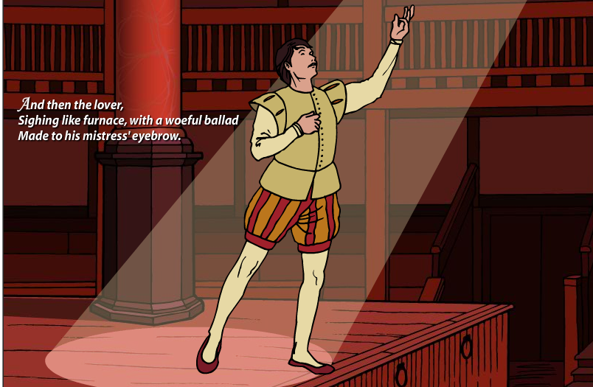 | With a formal voice like the narrator in a serious documentary.
At first the infant,  Mewling and puking in the nurse's arms. | At first we are a baby, crying and puking in the arm’s of our caregiver.
And then the whining school-boy, with his satchel  And shining morning face, creeping like snail  Unwillingly to school. | Then we are school kids, with our backpacks and happy faces, slowly and reluctantly going to school.
And then the lover,  Sighing like a furnace, with a woeful ballad  Made to his mistress' eyebrow. | Then we are young people in love—singing sad and silly songs to our loved one.

Then a soldier,  Full of strange oaths and bearded like the pard,  Jealous in honour, sudden and quick in quarrel,  Seeking the bubble reputation  Even in the cannon's mouth | Then we are naive fighters, quick to argue and eager to be heroic.
And then the justice,  In fair round belly with good capon lined,  With eyes severe and beard of formal cut,  Full of wise saws and modern instances;  And so he plays his part. | And then we are middle aged—fat and critical and formal.
The sixth age shifts  Into the lean and slipper'd pantaloon,  With spectacles on nose and pouch on side,  His youthful hose, well saved, a world too wide  For his shrunk shank; and his big manly voice,  Turning again toward childish treble, pipes  And whistles in his sound. | In our sixth stage, we become old, fragile and shoddy in appearance.
Last scene of all,  That ends this strange eventful history,  Is second childishness and mere oblivion,  Sans teeth, sans eyes, sans taste, sans everything. | Last we are like children again—no eyes, no teeth, no taste—nothing.
Part D: Dramatic Reading

Instructions
Create a dramatic recording of your reading of the excerpt from As You Like It on page 247 of your Sightlines 10 textbook. Use your notes from Section Assignment 4.1C to guide your reading. Contact your teacher to find out the best way to submit your reading.

Dramatic! Bring energy and emotion to the words that you read. Make sure that your audience knows what you are feeling.Effective! Use your voice to make your audience feel - fluctuate your volume, pitch, and rate of speech.Entertaining! Your lively performance can make your audience laugh, cry…

Step 1: Prepare your reading based on the notes created in the previous section assignment.

Step 2: Practise, practise practise! Read the excerpt to a partner and get feedback for improvement.

Step 3: Record the excerpt. Play it back and give yourself a mark out of four based on the evaluation guide. Then, make some final adjustments.

Step 4: Rerecord - submit this final recording to your teacher for evaluation.

One option for submission would be a First Class audio recording. To do this, please see the assignment online.

Indicate how you fulfill this component of the send in. I have sent this audio recording in as
( ).
Part E: A Secret and the Keeper - A Comparison

Introduction
You have completed the story comparison template and the Venn diagram. Now it is time to put all this pre-writing and pre-organizing to work for you. The notes, quotes, ideas, and impressions that you have jotted down will be the basis for the following multi-paragraph composition (essay) assignment.

Instructions
Topic:
- In a multi-paragraph composition, compare "Keeper 'n Me" and "The Secret Lost in the Water".
Your composition should:
- be approximately 350 words
- contain five paragraphs
  - introductory paragraph: 3-5 sentences
  - body paragraphs: 5-8 sentences
  - concluding paragraph: 3-5 sentences
- include one supporting quotation for each body paragraph

To get started:
Use the information you have gathered about the central characters, settings, the plot events, and voices in the stories as supporting details for your ideas.
Just as importantly, include your personal response to each story.
Have a clear thesis statement. An example: "Both of the memoirs are reflective looks back at Aboriginal childhoods, but the voice in ’Keeper 'n Me’ is filled with a quiet anger, while the voice in ’A Secret Lost in the Water’ is deeply sorry."

Step 1: A Secret and the Keeper – Outline Template
The following table is a variation on the standard outline template. Use the space provided to create an outline for your composition.

Introduction: | Personal Response plus a sentence that summarizes the main ideas of your multi-paragraph composition: a thesis statement such as, “Both of the memoirs are reflective looks back at aboriginal childhoods, but the voice in “Keeper’n Me” is rife with a quiet anger, while the voice in “A Secret Lost in the Water” is deeply sorry.” | Notes for your composition.
Body  Paragraph 1: | Comparison of central characters in each story
Body  Paragraph 2: | Comparison of plot events in each story (do not retell the story)
Body  Paragraph 3: | Comparison of voice in each story.
Conclusion: | Re-state your thesis, and make a concluding comment that ties your comparison composition together. For example, “Ultimately, both the story and the memoir are about remembering who you are and where you came from.” You may include any further personal comments about how you reacted to the two stories.

Step 2: Composition
Write your multi-paragraph composition based on your outline and the assignment requirements. Submit a polished draft for this section assignment.

( )
Part F: Your Story - Your Multi-paragraph Narrative Composition
Introduction
Here's your chance to tell your story, to think and write about yourself. Most of the rest of your English courses will ask you to write more formally and about the wider world. So, loosen up and have some fun when you write this composition. Be yourself, and be entertaining!
Instructions
Using your brainstorm and outline work to guide you, create a 250-350 word multi-paragraph narrative composition that has a central thesis and plenty of carefully selected and described details.

Remember that a narrative composition:
- is a story told from your first-person point of view
- makes and supports a central idea or point
- is filled with precise detail and description
- uses characters, plot, setting in order to illustrate the central idea
- may use dialogue
- usually begins with a character in conflict, and then by the end of the composition the conflict is resolved.
- includes a beginning and ending that explain the significance of the story

Be sure to submit all parts of this narrative composition, including:
- Writing Process Template
- Outline Template
- polished draft of your composition
Purpose: | Audience:
Topic: | Format:
Brainstorming Strategies
List ideas: | Mind Map:  Take key ideas and develop them into a mind map.

Polished Draft:

( )
Part G: Journal Entries (12 Marks)
InstructionsGather and submit the three Journal entries for this section.

Journal Entry 4.1 A: Modern Stories
R to one of the following topics. Your response may be personal, factual, or both.
- Stories, told or written, are valuable because they share the values that shapes a culture or people. What historical myths are you familiar with? How have those myths helped you to understand a particular culture?
- What do modern stories you read or see on TV teach you about the values of our culture today? Does our culture have anything in common with the Ancient Greeks or other ancient cultures? You may find it surprising to know that many modern movies parallel the Greek hero quests. For example, both the Star Wars series and The Matrix Trilogy base their plots on old Greek tales.
Now let's take a moment to experience a Greek myth first hand. Have you ever heard of the term, "a narcissist"? It refers to someone who loves him or herself above all else - people who are narcissists are so absorbed by their own perceived beauty, that they do not look at anyone else with love. People who look at themselves in the mirror all the time are also often referred to as narcissists.

The word narcissist comes from the story of the Greek god Narcissus, the beautiful son of the river God Cephissus and the nymph Leirope. When he spied his reflection in the water of a spring one day, he fell in love with himself, could not look away and died. The Greek myth of Echo and Narcissus has a clear lesson for its readers: see if you can figure it out.

( )

Journal Entry 4.1 B: Modern Balladeer
The ballad as a form has evolved over time. From its structured literary form popularized in the 18th century, the ballad in more recent time has evolved to become a form of popular song that is romantic or sentimental in nature. Select one of the following topics for your Journal:
1. Find an audio version of Stan Roger's ballad "White Squall." Describe how listening to the ballad in song format adds to your understanding or appreciation of the lyrics.
OR
2. Identify and describe two balladeers (singer/songwriters whose lyrics focus on the romantic or sentimental) with whom you connect. What is it about the stories they tell that captures your attention?

( )

Journal Entry 4.1 C: Multi-Paragraph Narrative Composition
After you have read the narrative composition, "None of the Above," answer the following questions in your Journal:
- How does Josh Freed's composition fit the characteristics of a narrative composition as listed in this lesson?
- Do you enjoy this kind of composition more than a formal composition? Why or why not?
( )

