English 10 Section 5.1 Assignment
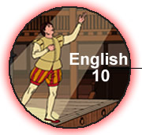 | Name:
 | NBCDES Student Number:
 | Date:
 | Marks: /41 = %

Remember to submit the following with this assignment:
Title From Marks
Part A: Will’s World - Truth Finder Lesson 5.1A 10
Part B: Keeping it Together Lesson 5.1D 5
Part C: Prologue Tragic Strip Lesson 5.1D 14
Part D: Journal Entries Lesson 5.1 12
Mark: /41

Part A: Will’s World - Truth Finder
Instructions
You've read, listened, and viewed a number of presentations on the life and times of William Shakespeare. Based on what you have learned in Will's World, determine if the following statements are true or false.

True or False

( ) 1) Shakespeare is known only for writing plays.

( ) 2) William married Anne Hathaway when he was 26 years old.

( ) 3) Bear baiting was a popular form of entertainment in Shakespeare's day.

( ) 4) At the Globe Theatre, the “groundlings” sat on the upper section of the gallery, which was partly covered.

( ) 5) Shakespeare wrote in two broad genres of plays: comedies and tragedies.

( ) 6) Queen Elizabeth I was a strong supporter of arts and culture.

( ) 7) A sonnet is a 16-line poem comprised of series of rhyming couplets.

( ) 8) The play Romeo and Juliet was written later in Shakespeare’s career.

( ) 9) Shakespeare wrote a total of 38 plays.

( ) 10) A soliloquy is a speech given on stage by one character to numerous other characters on stage at the same time.

Part B: Keeping it Together
Instructions
Based on what you have learned in this section, complete the following quiz by matching the terms with the correct definitions.
- Based on what you have learned in this section, record the word in the word bank with the correct definition from the words below. (Points: 5)

Word bank
Thou stars aside exeunt five
[ ] fate prologue Act III speakest

Matching pairs
( ) a) a verb with a suffix used in Shakespeare’s day
( ) b) an important idea or theme in the play
( ) c) contains the climax of the play
( ) d) these indicate stage directions
( ) e) two or more actors must leave the stage
( ) f) a pronoun Shakespeare uses
( ) g) the number of acts in Romeo and Juliet
( ) h) an important image in the play
( ) i) this gives the overview of the play
( ) j) the spoken thoughts of a character
Part C: Prologue Tragic Strip
Instructions

Draw a comic strip with seven panels. Each panel should represent two lines from the Prologue in pictorial form. For example, lines 1 and 2 would constitute one frame.The art work for the comic strip can by done by hand or by a graphics program on your computer. If you are drawing by hand, take a standard piece of paper and divide it into seven frames, or use the template provided.

In either case, the artwork should be 1) attractive 2) colourful and 3) accurately convey the action or content of the relevant lines.

An effective tragic strip would help someone who is unfamiliar with Elizabethan English understand the content of the prologue. You can download the file here and print it or add your content to the assignment template that you downloaded earlier.
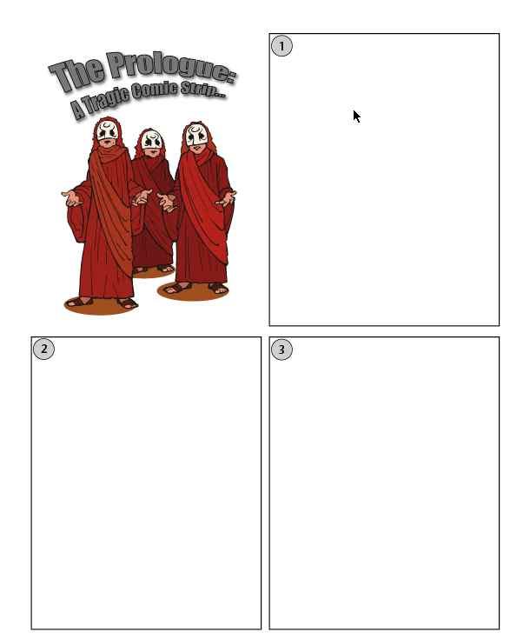
Type here

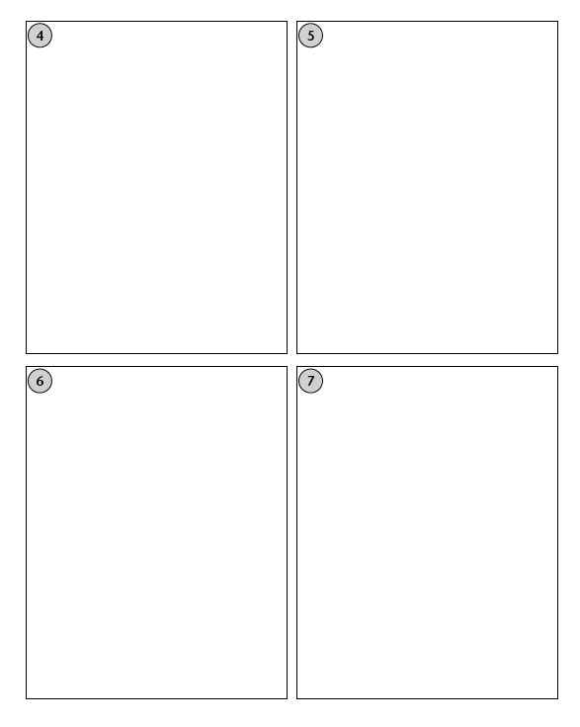

Part D: Journal Entries
Instructions
Gather and submit the three Journal entries for this section.

Journal Entry 5.1A: What Do You Know?
Now complete the first Journal Entry for this module. In the table provided, include three to five points under each column. If you know little about Shakespeare now, don't worry - you will be very familiar with him and his work at the end of this module.
What do I know about Shakespeare? | What do I want to know about Shakespeare?

Journal Entry 5.1B : What’s Your Idea of Good Entertainment?
In your journal, make a list and describe five standards you use to evaluate a movie. In your list, you might include such things as the type of movie, the acting, the characters, the special effects, the theme, and others. Using your list as a guide, describe at least one movie that stands out for you as your #1 pick.

( )

Journal Entry 5.1C: Decoding Shakespeare
You might find reading the prologue a little difficult at first. The English language changes and adapts to the times, so reading language from Shakespeare's time is understandably difficult. Also, this prologue is written in sonnet form! Count the number of lines: 14. So, you are reading complex poetry in an older version of English! A little decoding is needed here.
Below make a list of five to eight words in the prologue that are unfamiliar to you. Next, read the word in the context of the sentence and make an educated guess as to its meaning. Then, either look up the word in the dictionary, or see if a definition is provided on page 8 of your text. Include the word, your educated guess, and the dictionary definition in your entry.
( )

